**Datblygu Arfer a Gyfoethogir gan Ymarfer (DEEP)**

**Ymarfer myfyriol a chyd-gynhyrchiad**

**Cwrs hyfforddi *Cymuned o Ymholiad***

**Hanner diwrnod RHAD AC AM DDIM (ar-lein)**

**Beth yw DEEP?**

Mae DEEP yn ddull cyd-gynhyrchu o gasglu, archwilio a defnyddio mathau amrywiol o dystiolaeth mewn dysgu a datblygu gan ddefnyddio dulliau stori a deialog.

**Her cyd-gynhyrchu**

Er bod arfer myfyriol a chydgynhyrchu yn cael eu hyrwyddo’n eang, gall eu gwireddu fod yn dipyn o her. Rydym oll yn gweld y byd yn wahanol a gall dod â phobl â bwriadau da at ei gilydd i siarad yn y pen draw adael pawb yn rhwystredig os nad yw'r sgyrsiau'n mynd yn dda.

**Cymuned o Ymholiad fel dull o gefnogi cydgynhyrchu**

Cefnoga Cymuned o Ymholiad pobl i archwilio pwnc mewn ffordd sy'n gynhwysol, ond eto'n gwerthfawrogi ac yn cefnogi anghytundeb myfyriol. Mae’n helpu’r rhai sy’n cymryd rhan i fynd yn ‘DEEP’ wrth archwilio thema neu fater ac yn cynhyrchu hadau ar gyfer gweithredu.

**Cwrs y Gymuned Ymholi**

Cwrs hanner diwrnod yw hwn a fydd yn cyflwyno cyfranogwyr i’r egwyddorion allweddol y tu ôl i’r Gymuned Ymholi ac yn darparu canllaw cam wrth gam ar sut mae sefydlu a hwyluso sesiwn Cymuned Ymholi. Mae'r cwrs yn rhyngweithiol iawn, gan fod dysgu'n cael ei gyflawni trwy gymryd rhan mewn sesiwn Cymuned Ymholi.

**Pwy allai elwa o'r cwrs?**

Byddai’r cwrs o fudd i unrhyw un sydd â diddordeb mewn cyd-gynhyrchu, adeiladu tîm neu ymgynghori ac ymgysylltu. Bydd hefyd o ddiddordeb i hyfforddwyr sydd am helpu pobl i ymgysylltu â phwnc penodol ac ymchwilwyr, sy’n gallu defnyddio’r dull i gyd-gynhyrchu cwestiynau ymchwil.

**Gwybodaeth bellach am y cwrs**

Os hoffech chi gael gwybod mwy am y cwrs neu fynegi diddordeb mewn cymryd rhan, cysylltwch â Nick Andrews ar: [n.d.andrews@swansea.ac.uk](mailto:n.d.andrews@swansea.ac.uk)

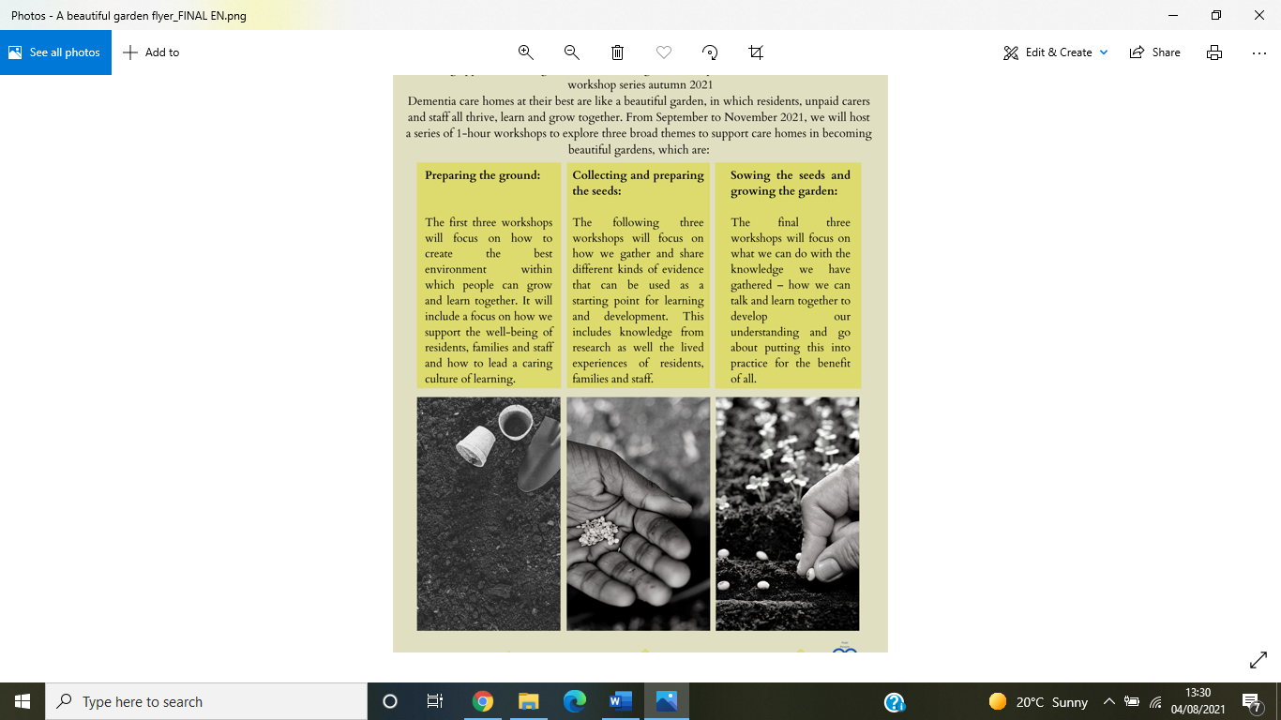

**Developing Evidence Enriched Practice (DEEP)**

**Reflective practice and co-production**

***Community of Enquiry* training course**

**FREE half day (online)**

**What is DEEP?**

DEEP is a co-production approach to gathering, exploring and using diverse types of evidence in learning and development using story and dialogue-based methods.

**The challenge of co-production**

Whilst reflective practice and co-production is widely promoted, making them a reality can be challenging. We all see the world differently and bringing well-intentioned people together to talk can end up leaving everyone frustrated if the conversations do not go well.

**Community of Enquiry as a method to support co-production**

Community of Enquiry supports people to explore a topic in a way that in inclusive, yet values and supports reflective disagreement. It helps participants to go ‘DEEP’ in exploring a theme or issue and generates the seeds for action.

**The Community of Enquiry course**

This is a half-day course which will introduce participants to the key principles behind Community of Enquiry and provide a step-by-step guide on how to set up and facilitate a Community of Enquiry session. The course is highly interactive, as learning is achieved through being involved in a Community of Enquiry session.

**Who might benefit from the course?**

The course would benefit anyone with an interest in co-production, team building or consultation and engagement. It will also be of interest to trainers who want to help people engage with a particular subject and researchers, who can use the method to co-produce research questions.

**Further information about the course**

If you would like to find out more about the course or express an interest in participating, please contact Nick Andrews at:

[n.d.andrews@swansea.ac.uk](mailto:n.d.andrews@swansea.ac.uk)

